TOOL AND MACHINERY GUIDE
 | 402-253-2772  WEBSITE: WCWRAIL.COM

Title: Break-Away Split Ring Pliers | Prepared By: Wulf's Custom Welding
Document No. 0307 | Date: May 7, 2010

SUBJECT: BREAK-AWAY SPLIT RING PLIERS

Capacity: This tool is used to spread the wires on Break-Away Split Rings. It does not require a rated capacity.

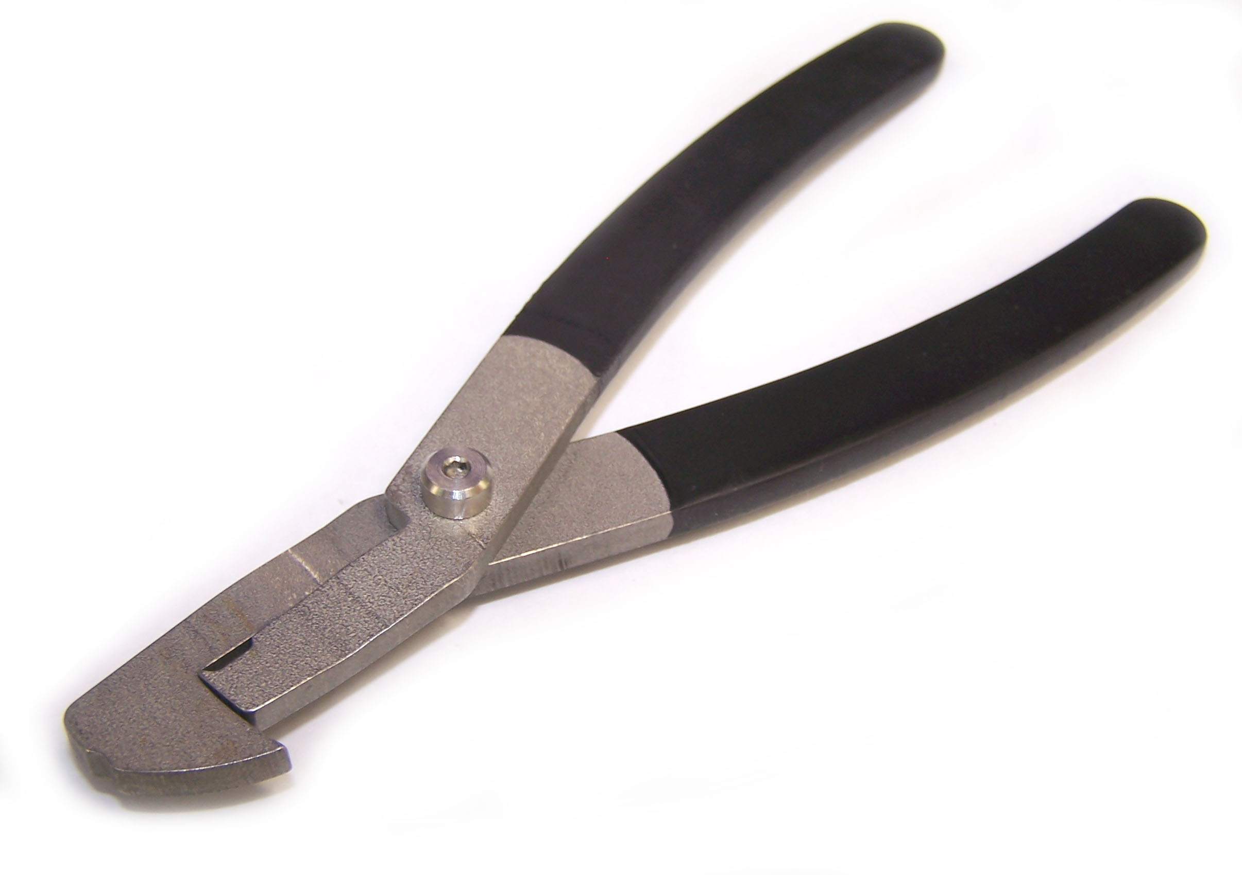

FIGURE 1

TECHNICAL SPECIFICATIONS:
Available Through:

Wulf’s Custom Welding
19102 So. 156th Street
Omaha, NE 68059
Tel: 402-253-2772
Fax: 402-253-9092
Website: wcwrail.com
Reference Part Number: 0307

Fixture Weight: Less Than One Pound
Base Construction Material: Stainless Steel With Rubber Grips

DESCRIPTION:

This tool is used to open the Break-Away Split Rings used with locomotive end platform cross-over chain assemblies. It has no other intended uses, and must not be used as a conventional pair of pliers.
INSTRUCTIONS FOR USE:
BREAK-AWAY SPLIT RING WIRE OPENING:
WARNING: Ensure Blue Flag protection is set in accordance with current operating rules before fouling any track or performing any type of repair work.

WARNING: Ensure locomotive(s) is/are properly secured with hand brakes before attempting to perform coupler removal or installation.

- Inspect the pliers prior to use. If the pliers halves are loose, use wrenches to tighten the elastic lock nut. Make sure the pliers move freely after tightening (Figure 1).
- Grasp the bottom of the split ring with one hand. Place the lower pliers jaw under the split ring. The pliers may be placed under one or two rings for opening. We recommend using two rings for better stability (Figure 2).
- Apply pressure to the pliers until the split ring fully opens. Twist the ring upward slightly until the ring wire engages in the small detent located on the front face of the upper pliers jaw. Make sure you keep your fingers away from the open portion of the ring to avoid pinching (Figure 2).
- While holding the pliers, insert the required chain components and/or latch into the open split ring loop. Grasp the bottom of the split ring, release pressure on the pliers, and twist the pliers handles downward slightly to disengage the split ring wire from the upper jaw detent. Again, make sure you keep your fingers away from the open portion of the ring to avoid pinching (Figure 3).

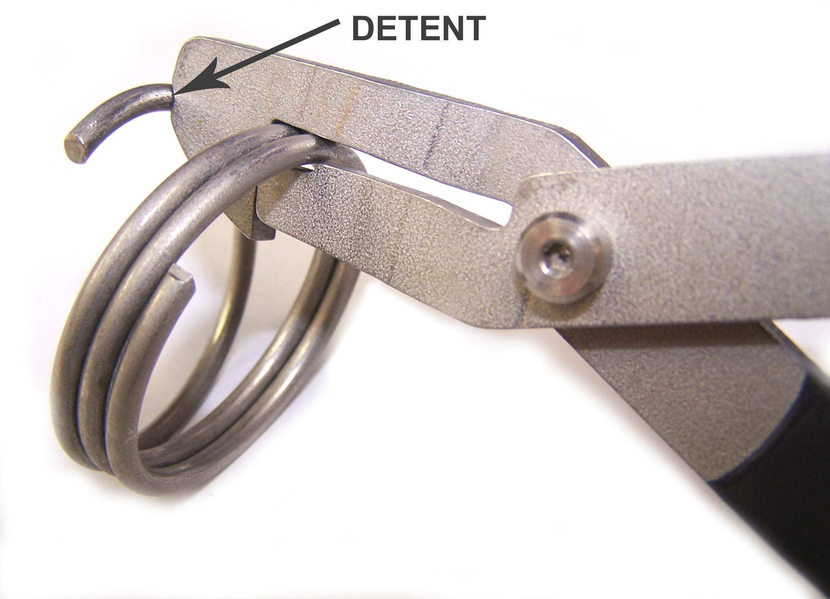 | 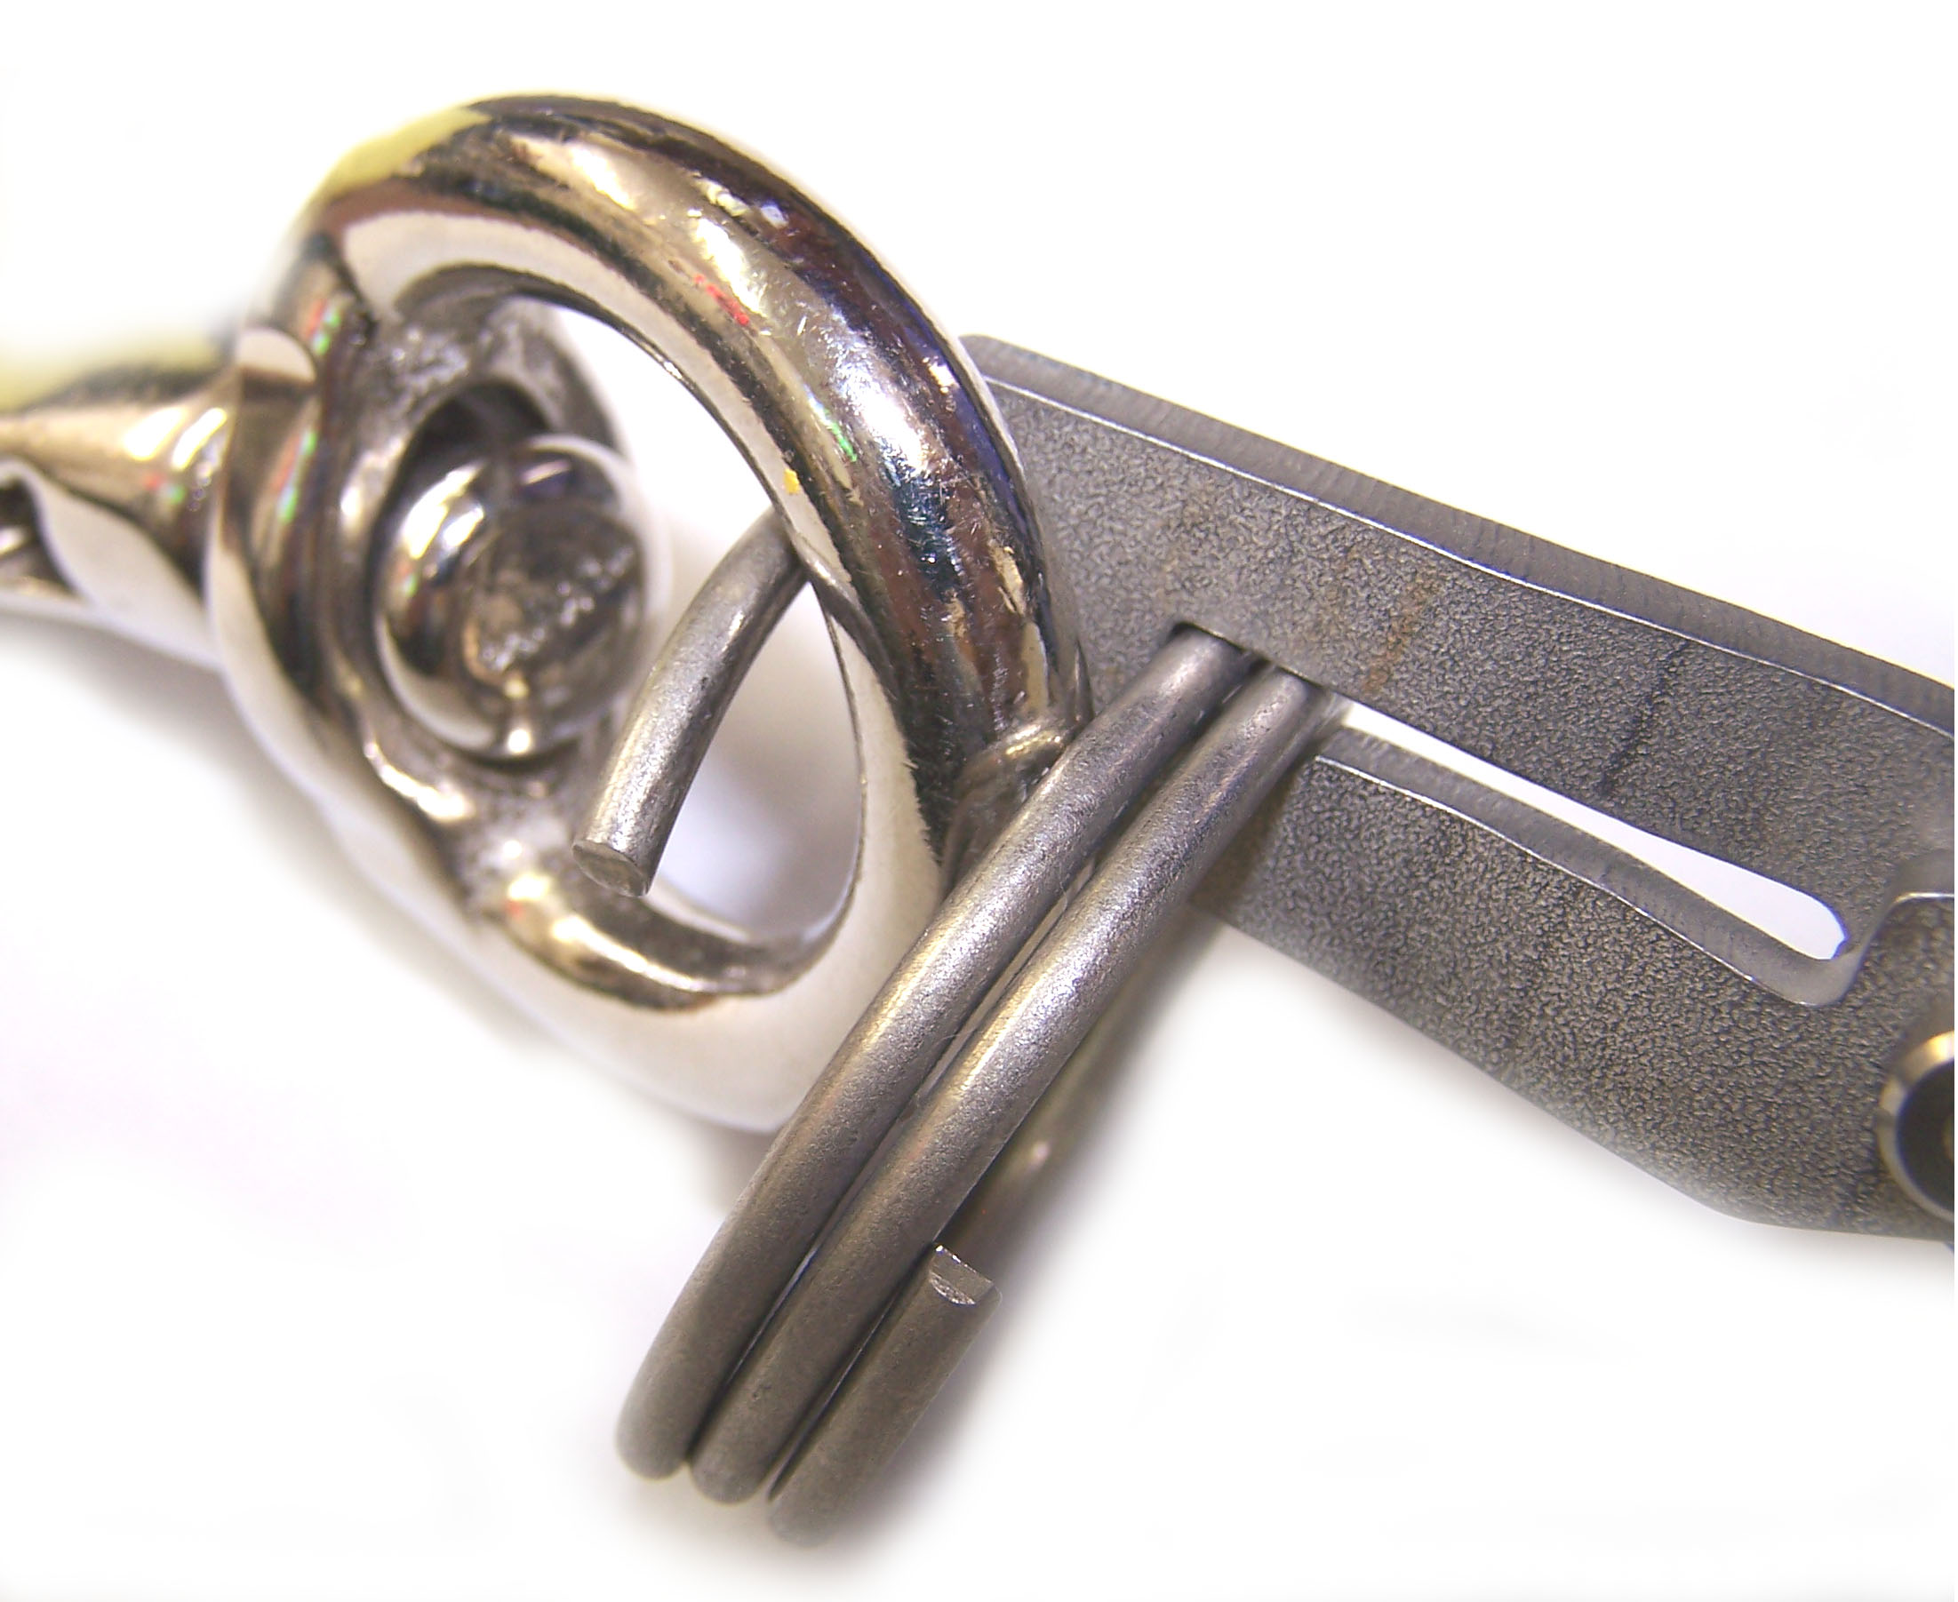
FIGURE 2 | FIGURE 3

- Thread the chain components and/or latch through the split ring loops until they are fully engaged and the ring closes. Inspect the pliers again, and place them into their proper place of storage (Figure 3).

SAFETY PRECAUTIONS:
WARNINGS: Noncompliance could cause injury to employees
CAUTIONS: Noncompliance could cause damage to equipment
NOTES: Pertinent information
- WARNING: Wear personal protective equipment in accordance with Safety and General Rules as required.
- WARNING: Leather or other protective gloves should be used when opening AND closing split rings to protect against potential pinch points.
- CAUTION: Never use these pliers for any purpose other spreading Break-Away Split Ring wires. Use as conventional pliers will damage this tool.

