TOOL AND MACHINERY GUIDE
Title: LONG SHANK COUPLER STORAGE RACK | Issued By: Wulf’s Custom Welding
Title: LONG SHANK COUPLER STORAGE RACK | Prepared By:
Document No.: 0416
Date: February 10, 2012 | Revision: | Date Revised:

SUBJECT: LONG SHANK COUPLER STORAGE RACK

Capacity: This fixture has a rated capacity of ten each long shank E or F style couplers or 8,000 Pounds.

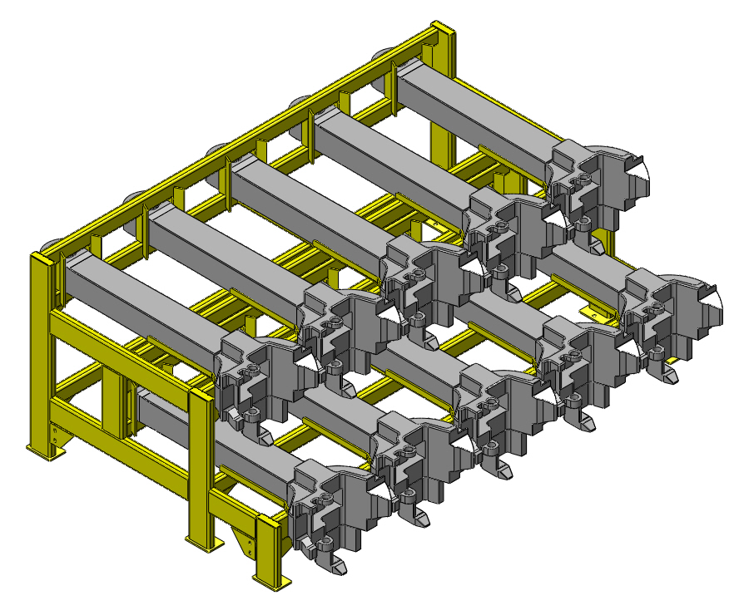

FIGURE 1

TECHNICAL SPECIFICATIONS:

Available Through:
Wulf’s Custom Welding
19102 So. 156th Street
Springfield, NE 68059
Tel: 402-253-2772
Fax: 402-253-9092
Website: wcwrail.com

Reference Part Number: 0416

Fixture Weight: 1,625 Pounds

Base Construction Material: Steel

DESCRIPTION:

This rack is used to store ten each E or F style long shank couplers. It has no other intended uses. It cannot be used to store conventional length couplers.
INSTRUCTIONS FOR USE:
LONG SHANK COUPLER STORAGE RACK
WARNING: Ensure car(s) is/are properly secured with hand brakes and/or chocks before attempting to perform any component repairs.

WARNING: Ensure Blue Flag protection is set in accordance with current operating rules before fouling any track or performing any type of repair work.

- Place the coupler into the rack for storage using any approved coupler lifting fixture. The Single Tine Coupler Lifter, Item Number 630106, will work well for this application.
- Remove the coupler from the rack for installation in the freight car using any approved coupler lifting fixture. Use the fixture to take the coupler to the car for installation into the draft gear.
- When coupler installation is complete, inspect the coupler lifting fixture, and place it back into its normal place of storage.

ERGONOMIC/SAFETY ADVANTAGES:
- Keeps long shank couplers stored in a convenient location for access.
- Eliminates the need to store long shank couplers in an upright position.

SAFETY PRECAUTIONS:
WARNINGS: Noncompliance could cause injury to employees
CAUTIONS: Noncompliance could cause damage to equipment
NOTES: Pertinent information
- WARNING: Wear personal protective equipment in accordance with current Safety Rules and Regulations as required.
- WARNING: Follow all current rules and regulations regarding the use of forklifts or overhead cranes.
- WARNING: Never place any part of your body under a suspended load.
- WARNING: This rack is designed for long shank couplers only. Do not attempt to store conventional length couplers in this rack.
- WARNING: Review and follow the instructions for the use of the coupler lifting fixture.

