TOOL AND MACHINERY GUIDE
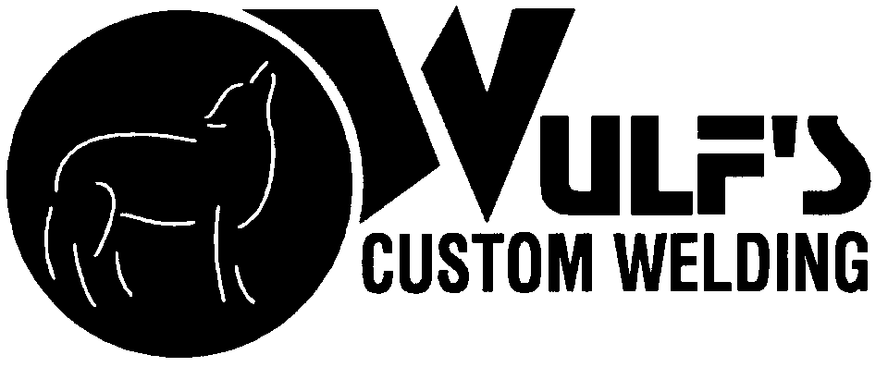 | 402-253-2772  WEBSITE: WCWRAIL.COM

Title: Roller Bearing Adaptor Handling Tool | Prepared By: Wulf's Custom Welding
Document No. 0284 | Date: February 21, 2011

SUBJECT: ROLLER BEARING ADAPTOR HANDLING TOOL
Capacity: This tool is used to remove or install typical roller bearing adaptors. The rated capacity is 100 pounds.

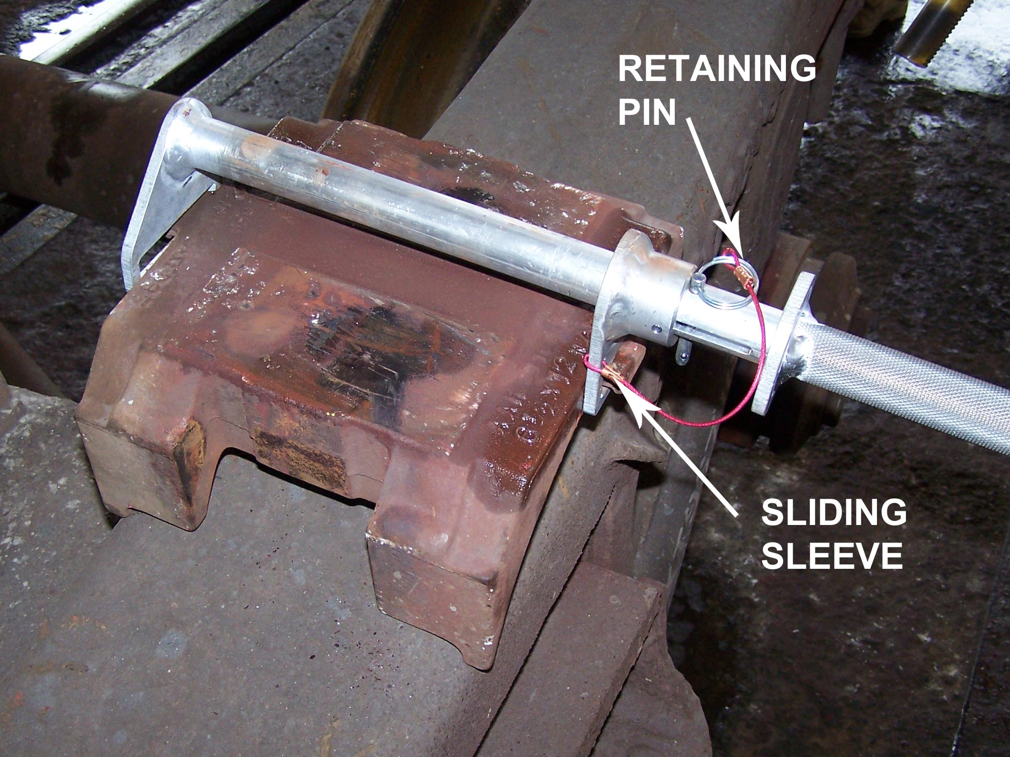 | 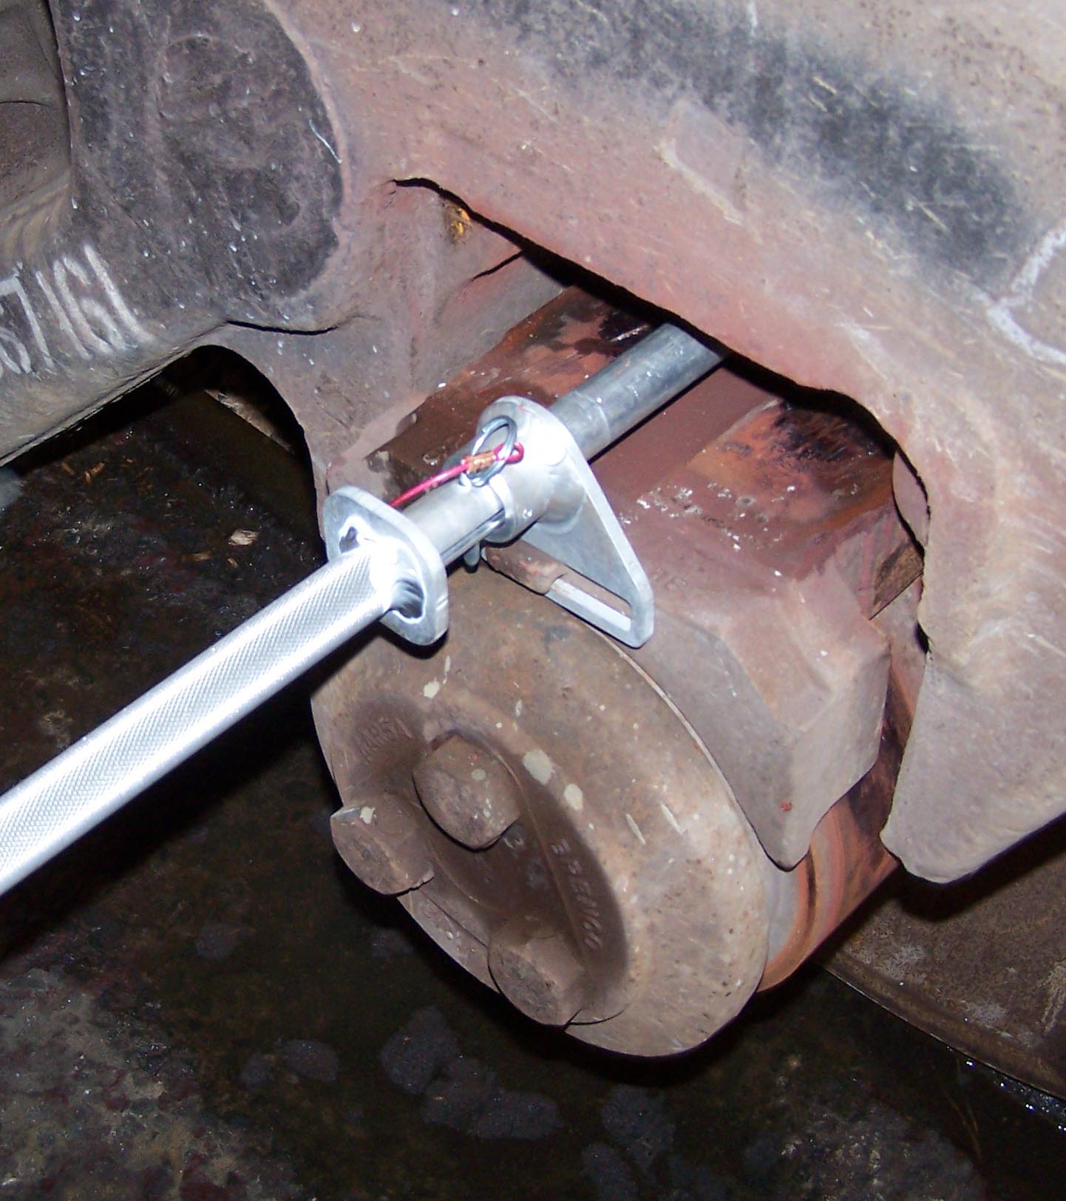
FIGURE 1 | FIGURE 2

TECHNICAL SPECIFICATIONS:

Available Through:

Wulf’s Custom Welding
19102 So. 156th Street
Springfield, NE 68059
Tel: 402-253-2772
Fax: 402-253-9092
Website: wcwrail.com
Reference Part Number: 0284
Fixture Weight: 2 Pounds
Base Construction Material: 6061 Aluminum

DESCRIPTION:

This tool is used to pick up and remove or install roller bearing adaptors. It has no other intended uses.
INSTRUCTIONS FOR USE:
ROLLER BEARING ADAPTOR HANDLING TOOL:
WARNING: Ensure Blue Flag protection is set in accordance with GSR 1300 before fouling any track or performing any type of repair work.

WARNING: Ensure car(s) is/are properly secured with hand brakes before attempting to perform side bearing roller installation.

- Inspect the Roller Bearing Adaptor Tool for defects prior to use. Make sure the retaining pin is in place (Figure 1).
- Raise the side frame far enough to allow removal of the bearing adaptor.
- Remove the retaining pin and move the sliding sleeve the outward position (Figure 1).
- Place the rearward holder on the tool over the bearing adaptor lifting tine (Figure 2).
- Slide the tool sleeve forward until it fully engages the other bearing adaptor lifting tine (Figure 2).
- Insert the retaining pin through the sleeve. Various holes are provided to securely grip different sizes and types of bearing adaptors (Figure 2).

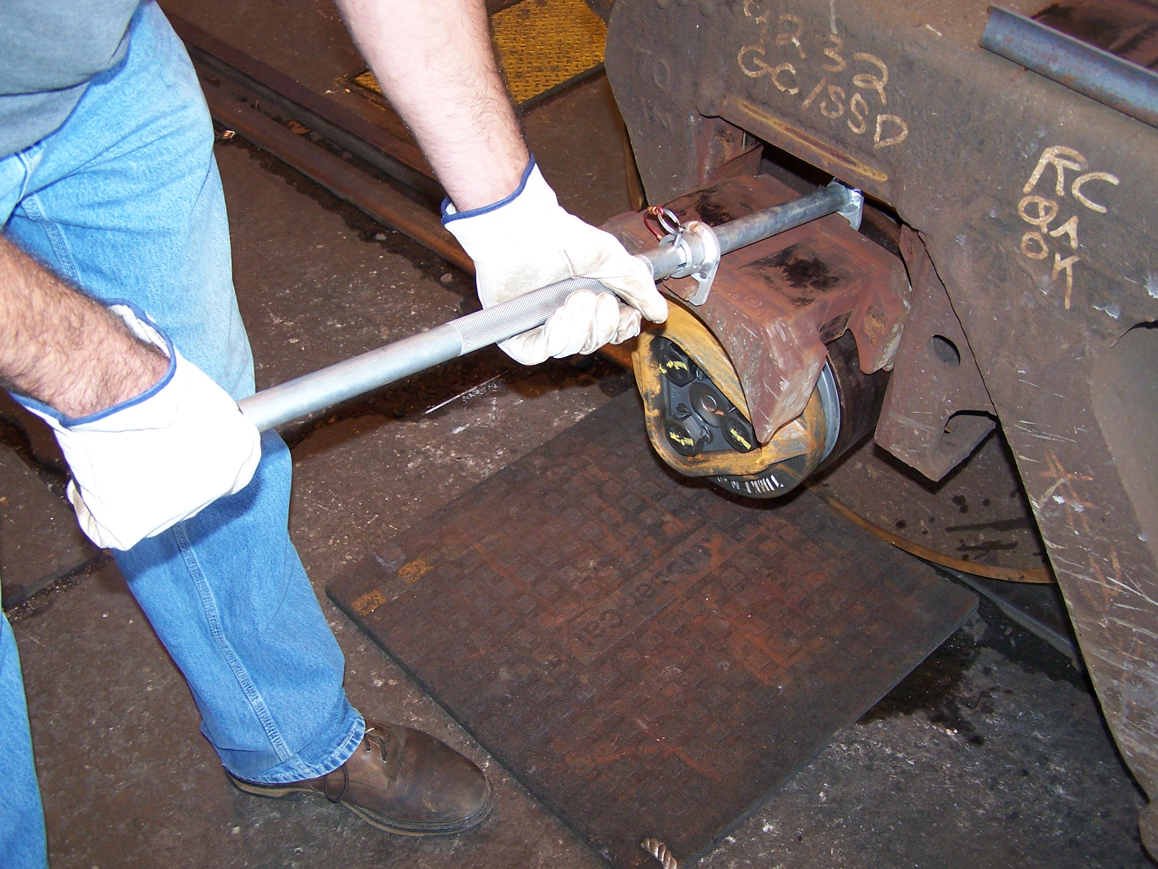

FIGURE 2

- Remove the bearing adaptor from the side frame. Remove the retaining pin and slide the sleeve to the outward position to release the bearing adaptor (Figure 3).
- Reverse the above procedure to install the bearing adaptor back into the side frame.

SAFETY PRECAUTIONS:
WARNINGS: Noncompliance could cause injury to employees.

CAUTIONS: Noncompliance could cause damage to equipment
NOTES: Pertinent information

- WARNING: Wear personal protective equipment in accordance with Safety and General Conduct Rule 1040 as required.
- WARNING: Never place any portion of your body directly under the roller bearing adaptor during handling.
- WARNING: Always handle the tool using the provided knurled surface and hand grip to avoid pinch points.
- CAUTION: Never use the Roller Bearing Adaptor Tool for any purpose other than removing or installing roller bearing adaptors.
- CAUTION: Make sure the retaining pin is fully seated before lifting the roller bearing adaptor.

