TOOL AND MACHINERY GUIDE
Title: Side Frame Support Stands | Issued By: Wulf’s Custom Welding
Title: Side Frame Support Stands | Prepared By: Wulf’s Custom Welding
Document # 27-4051?
Date: February 27, 2013 | Revision: | Date Revised:
SUBJECT: SIDE FRAME SUPPORT STANDS
Capacity: These stands have a rated capacity of 4,000 pounds each.
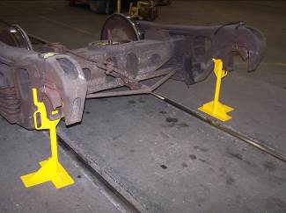 | 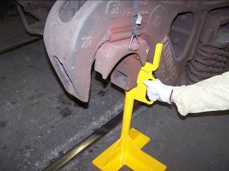
FIGURE 1 | FIGURE 2

TECHNICAL SPECIFICATIONS:
Available Through:
Wulf’s Custom Welding
19102 So. 156th Street
Springfield, NE 68059
Tel: 402-253-2772
Fax: 402-253-9092
Website: wcwrail.com
Reference Part Number: 28” Stand Height – 0421
26” Stand Height – 0421-1

Fixture Weight: 35 Pounds Each
Base Construction Material: Grade 50 Steel

DESCRIPTION:

These stands are used to support the side frames during wheelset removal while using a forklift. They make wheelset replacement possible using a forklift at locations where jib or overhead type cranes are not available.
INSTRUCTIONS FOR USE:
SIDE FRAME SUPPORT STANDS:
WARNING: Ensure freight car(s) is/are properly secured with hand brakes and/or chocks before attempting to perform any truck repairs.

WARNING: Ensure Blue Flag protection is set in accordance with current operating rules before fouling any track or performing any type of repair work.

- Inspect the stands for defects. Remove the stands from service if any broken welds or deformation is found.

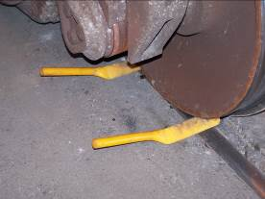 | 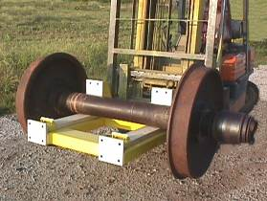
FIGURE 3 | FIGURE 4

- Remove the truck assembly from under the freight car using standard approved maintenance procedures. Remove the side frame pedestal keys if they are installed.
- Use an approved wheelset handling system with a non-marring contact surface to lift the wheelset far enough to place the Side Frame Support Stands under the side frames (Figure 4 & 1).
- Place the Side Frame Stands under the side frame in the pockets located directly behind the pedestal casting (Figure 2). Use the provided handles for placement. Do not place your hands or fingers on top of the fixture.
- Apply chocks under the opposite wheelset to make sure the truck does not move when it is lowered (Figure 3).
- Lower the wheelset with the forklift, allowing the side frames to rest on the Support Stands (Figure 1).
- Continue to lower the wheelset, and remove it from the truck assembly.
- Place the new wheelset on the installation fixture and move it into position under the side frames.
- Raise the wheelset into position, and raise the side frames far enough to remove the Side Frame Stands. Make sure the roller bearing adaptors are correctly seated on the roller bearings.
- Remove the stands and put them into their normal place of storage. Use the provided handles for removal (Figure 2). Do not place your hands or fingers on top of the fixture

ERGONOMIC/SAFETY ADVANTAGES:
- Allows replacement of wheelsets with forklifts at facilities that do not have jib or overhead type cranes.
- Handles are provided for easy placement and removal under the side frame.

SAFETY PRECAUTIONS:
WARNINGS: Noncompliance could cause injury to employees
CAUTIONS: Noncompliance could cause damage to equipment
NOTES: Pertinent information
- WARNING: Wear personal protective equipment in accordance with Safety and General Rules as required.
- WARNING: Always keep all parts of your body out from under any suspended equipment or load.
- WARNING: Avoid pinch points. Always use the provided handles to install and/or remove the stands. Never place your hand or fingers between the side frames, wheels, or bearing adaptors.
- WARNING: These stands must always be installed and used in a pair of two on both side frames. Never use a single stand for support.
- CAUTION: These stands are designed to support the side frames during wheelset removal. They have no other intended uses.

